# Simulation and Measurement

## Input Characteristics

**For V**

**cc**

**=**

**8**

**V**

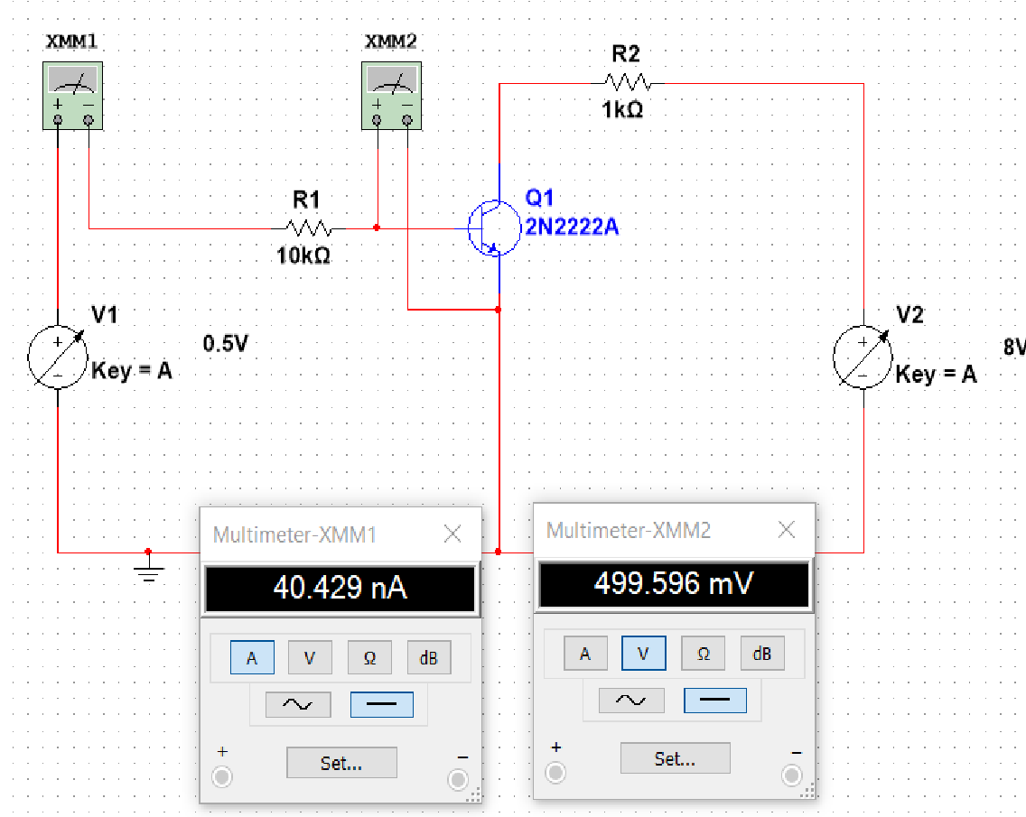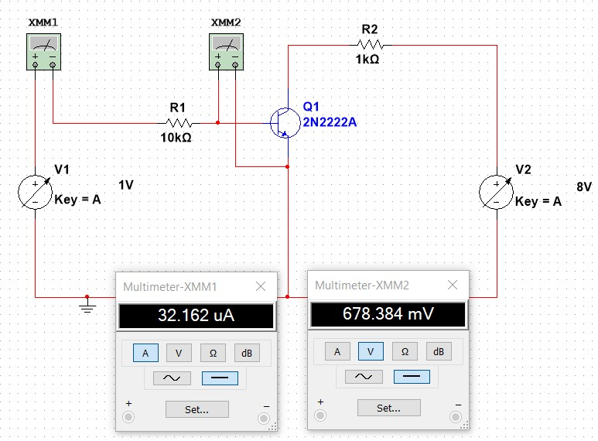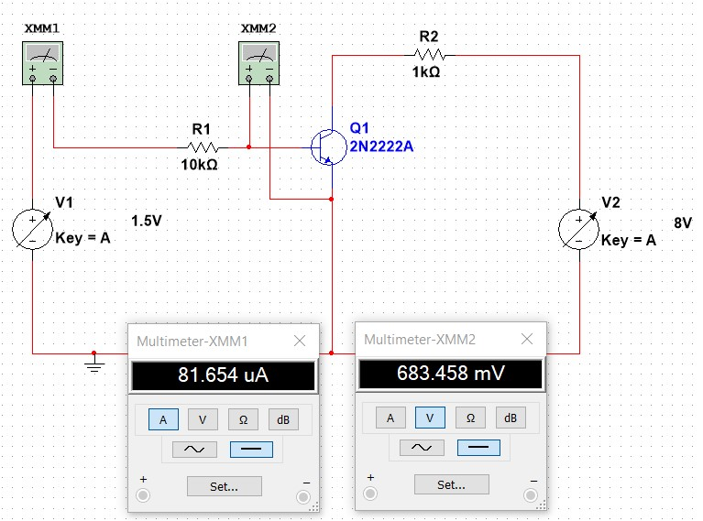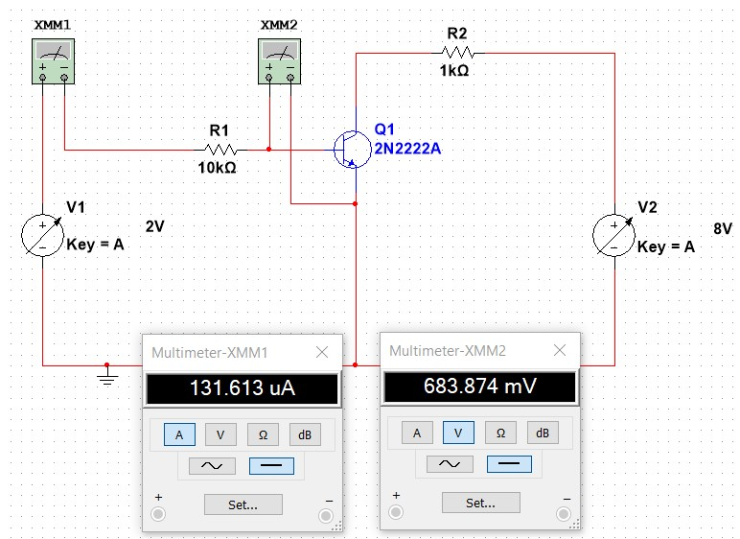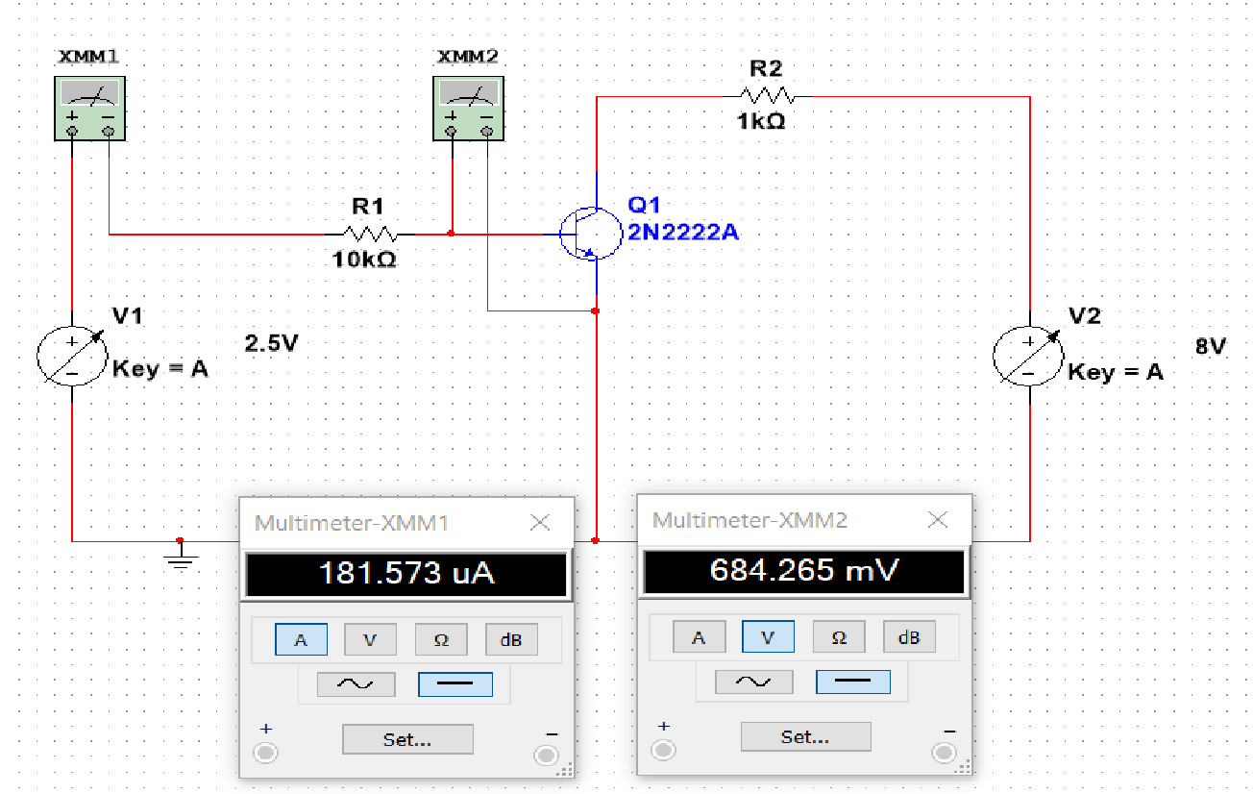

**For V**

**cc**

**=**

**16**

**V**

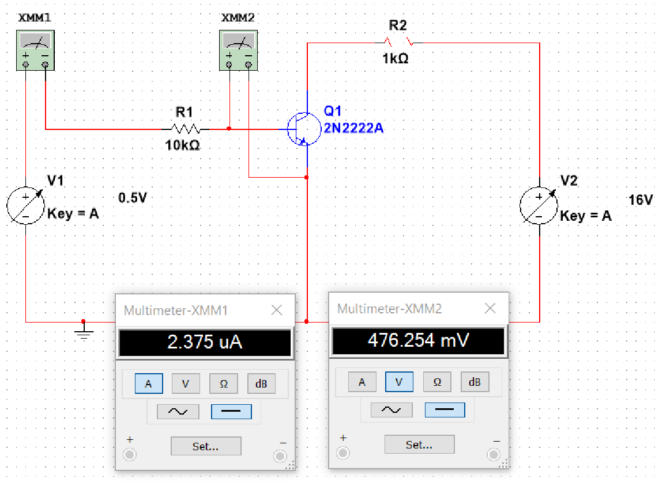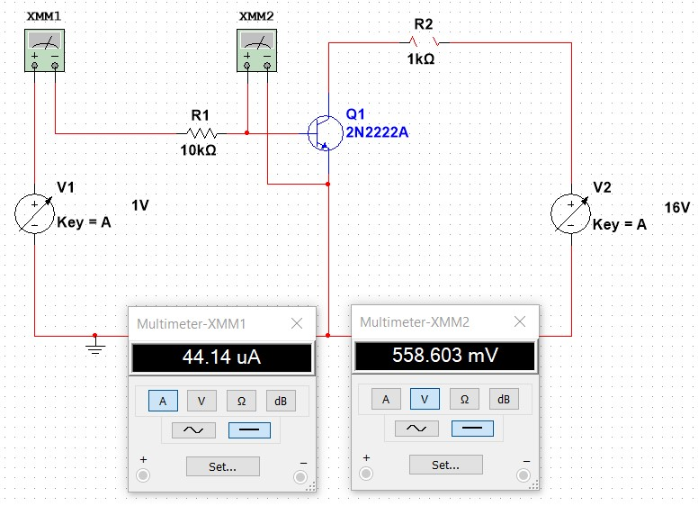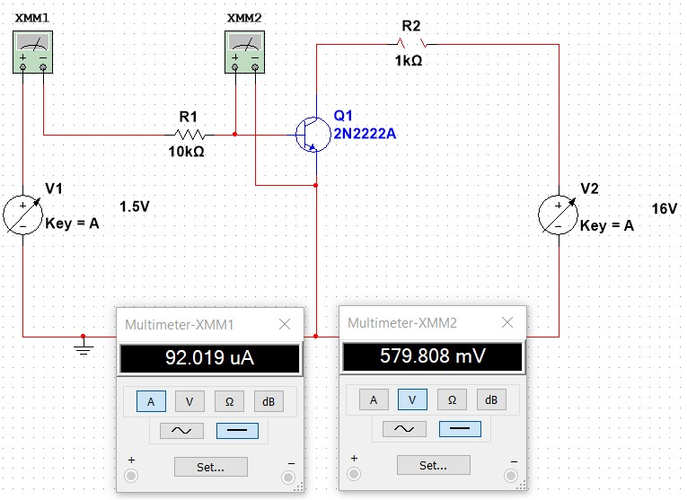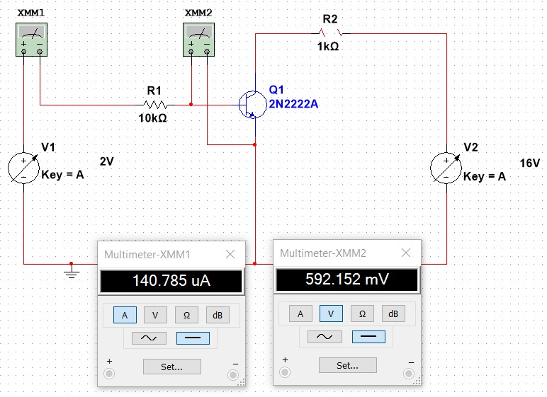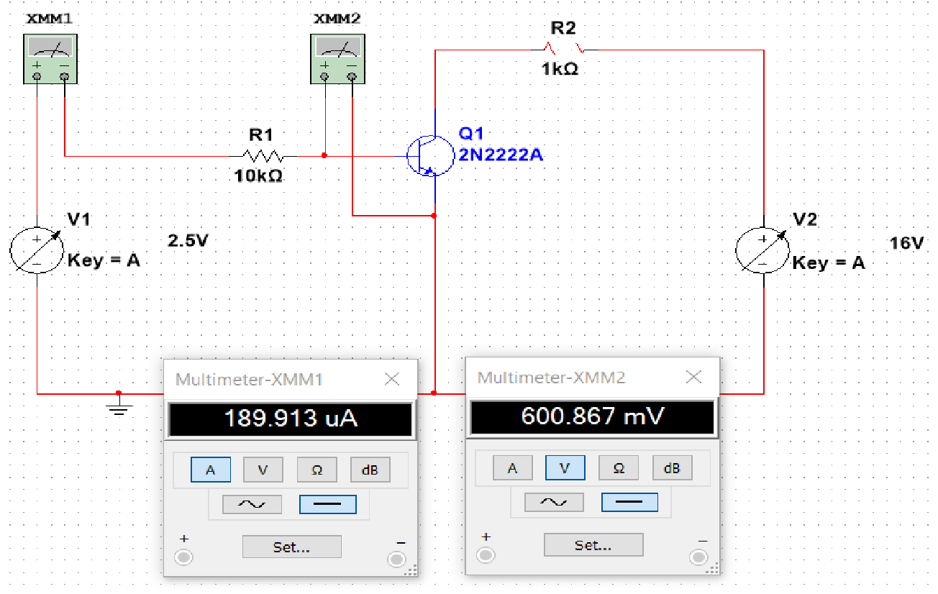

**Out**

**put Characteristics**

**For**

**I**

**B**

**=**

**0**

𝝁𝑨

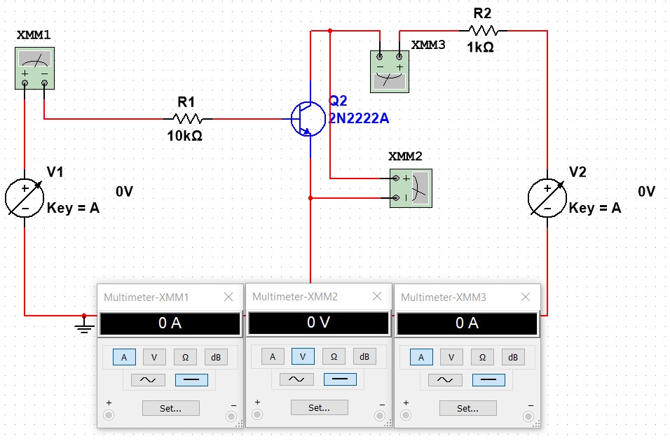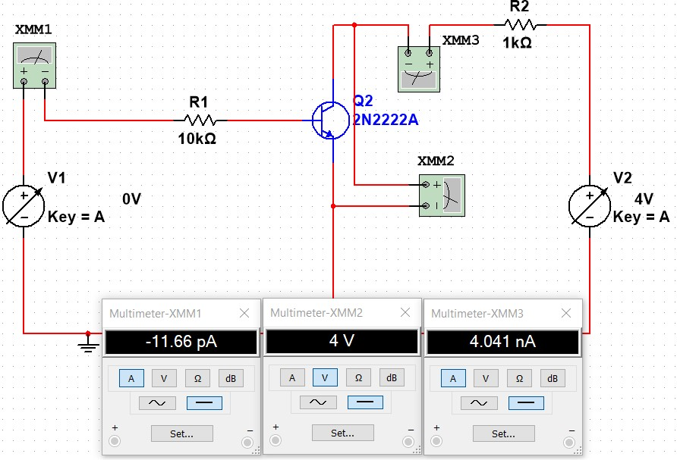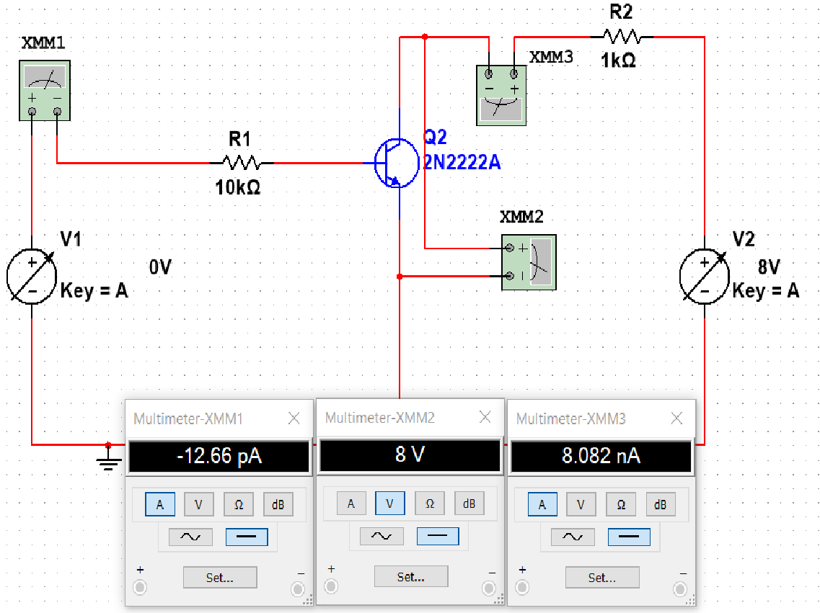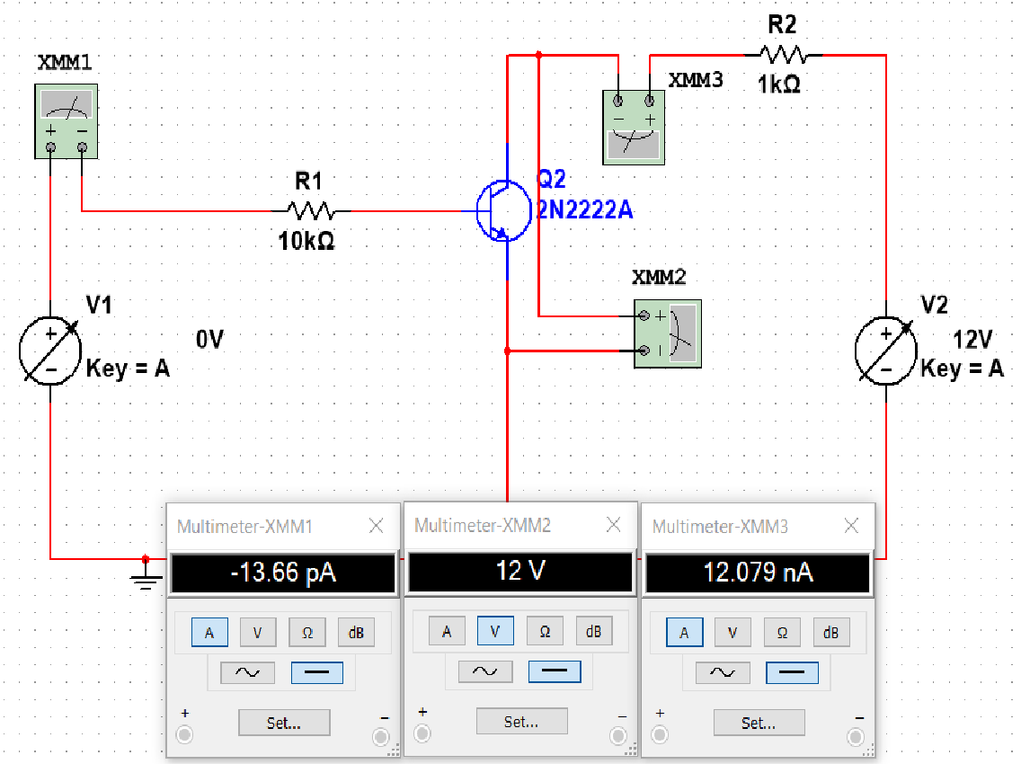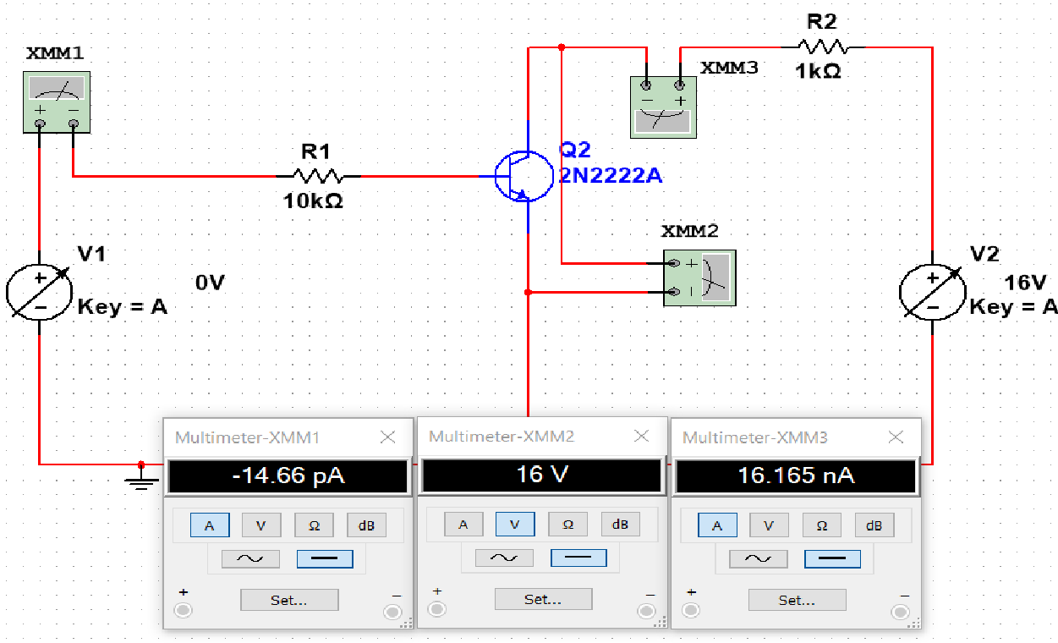

**For**

**I**

**B**

**=**

**50**

𝝁𝑨

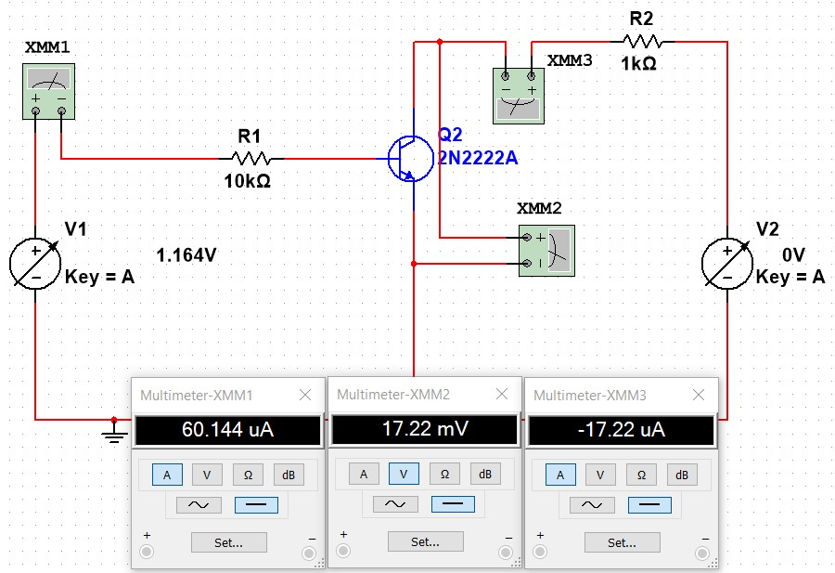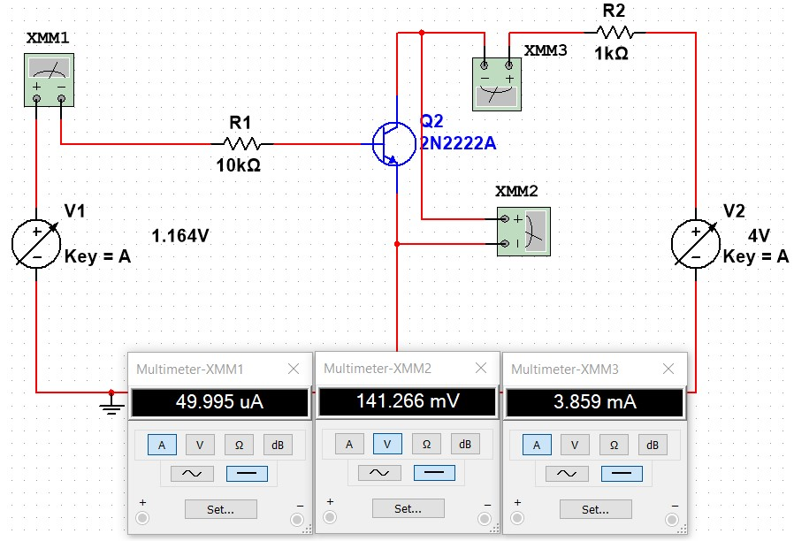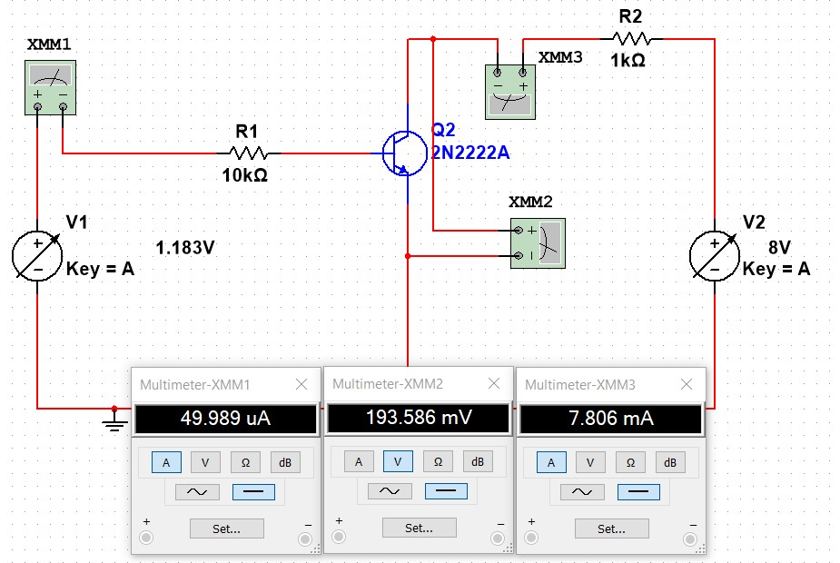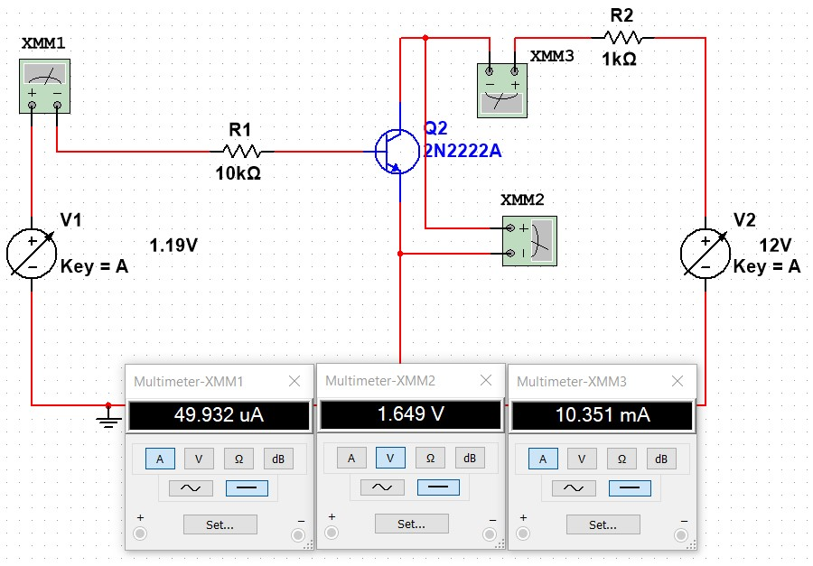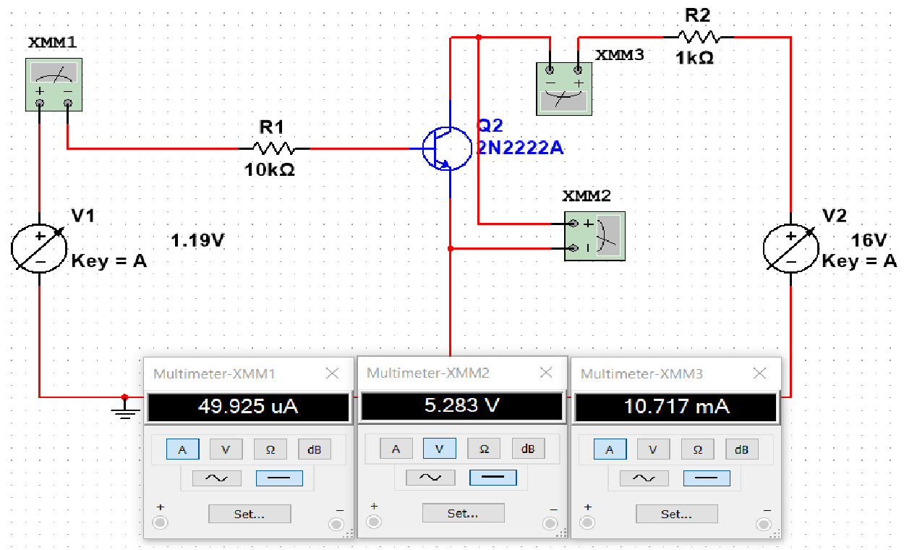

**For**

**I**

**B**

**=**

**10**

**0**

𝝁𝑨

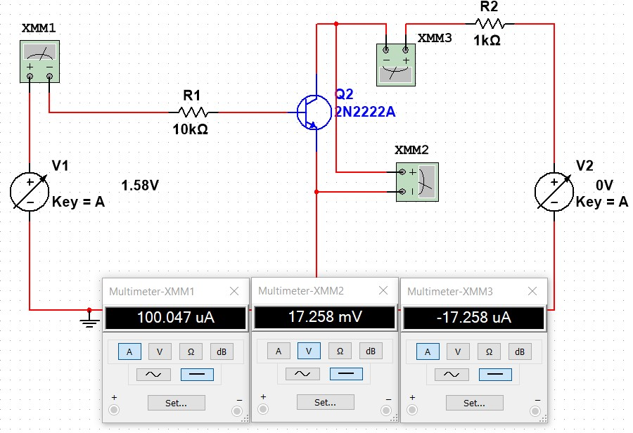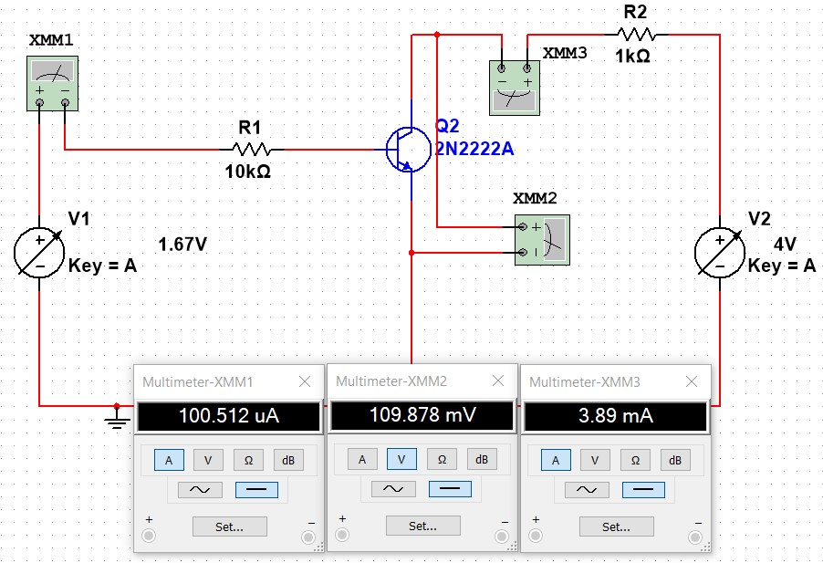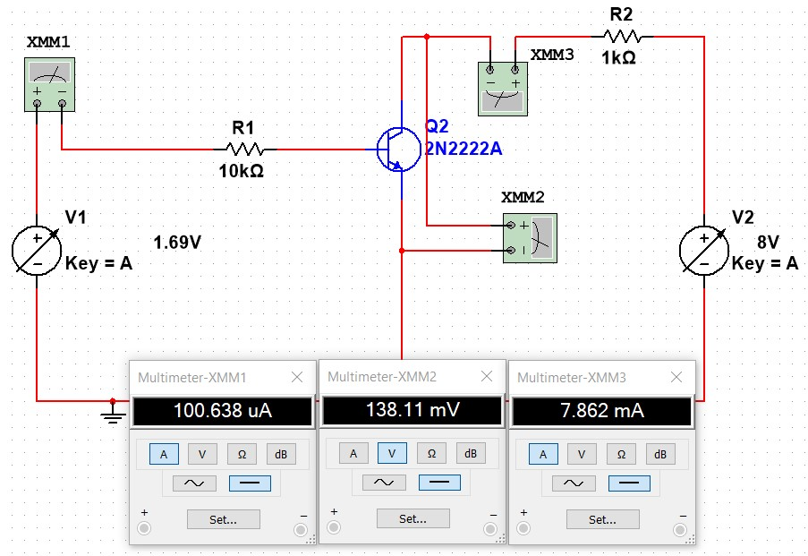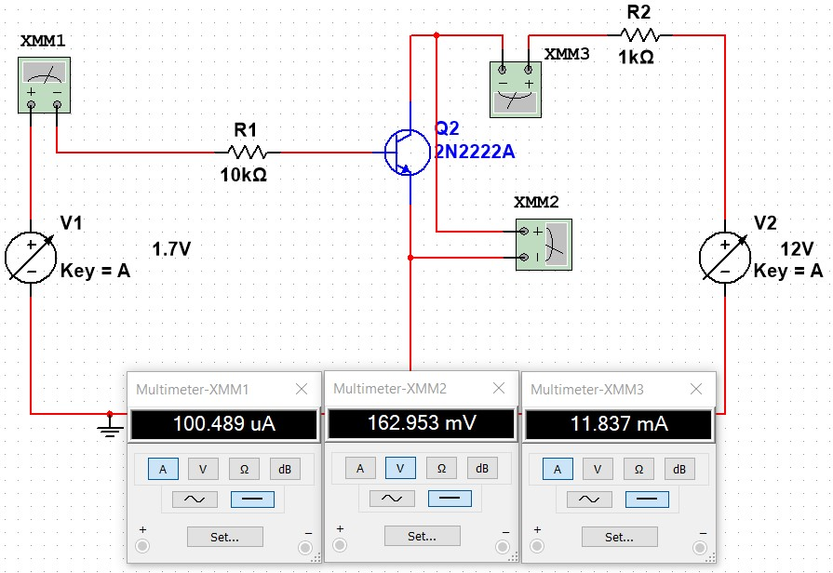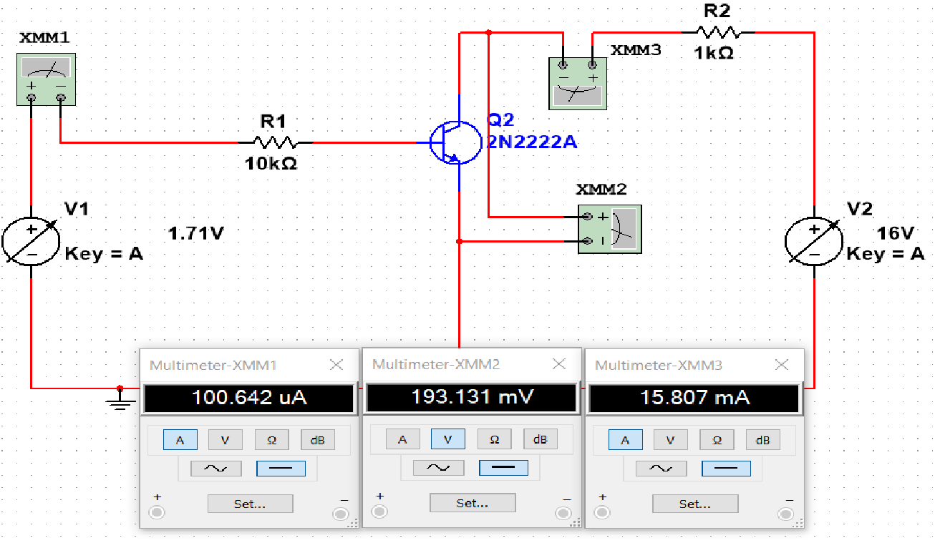

**Circuit Diagram:**

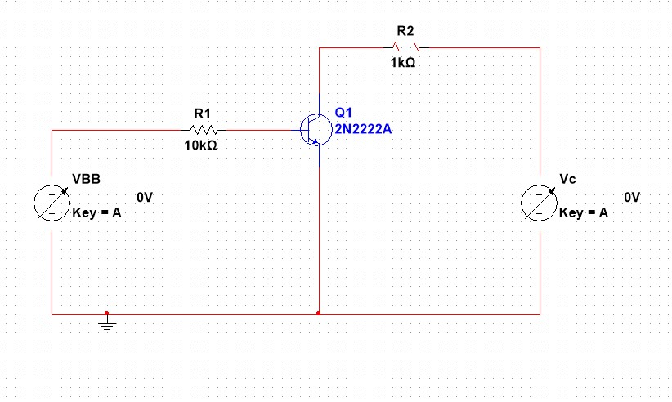

## Input Characteristics

-50

0

50

100

150

200

250

0

0.2

0.4

0.6

0.8

IB (

𝝁

𝑨

**)**

VBE (v)

Input Characteristics

VCC = 8V

-50

0

50

100

150

200

250

0

0.2

0.4

0.6

0.8

IB (

𝝁

𝑨

**)**

VBE (v)

Input Characteristics

VCC = 16

V

## Output Characteristic

-2

0

2

4

6

8

10

12

0

1

2

3

4

5

6

IC (mA)

VCE (v)

Output Characteristic

IB = 50

𝝁

𝑨